Use-Case Realization Report (Requirements)
Propose New Project

Issue 1.0
Revision History
Date | Issue | Description | Author

Table of Contents
1. Brief Description 4
2. Flow of Events 4
2.1 Standard Flow 4
2.2 Exceptions 4
3. Interaction Diagrams 4
3.1 Domain Collaboration Diagram: Propose New Project 4
4. Participating Objects 4
5. Derived Requirements 4

Use-Case Realization Report
Propose New Project

Brief Description
The use case enables registered user to propose new project.

Flow of Events
The standard flow of events for this use case and any exceptions are described in the following subsections. See section 3.1 for an overview of the participating Actors and Domain Objects.

Standard Flow

Precondition: User has logged in the system

This use case provides the user interface related functionality that will be provided to the User, as follows:
- The User clicks ‘Propose New Project’ link and the system is redirected to NewProjectScreen.
- The project creation form will be displayed on the NewProjectScreen, including the following fields:
- Project Name
- Project Description
- Country
- Location
- Estimated Duration
- Proposer

- The User can edit the form.
- The form is submitted when user click ‘Create’ button
- The system will validate the form information
- After validation, the system will save the project information
- The proposed user will be automatically added to the ProjectInterest

Exceptions
The following exceptions have been identified:
- Invalid Information Format. If any of input info is incompatible, system will give a validation summary for user to make corrections

Interaction Diagrams

Domain Collaboration Diagram: Propose New Project
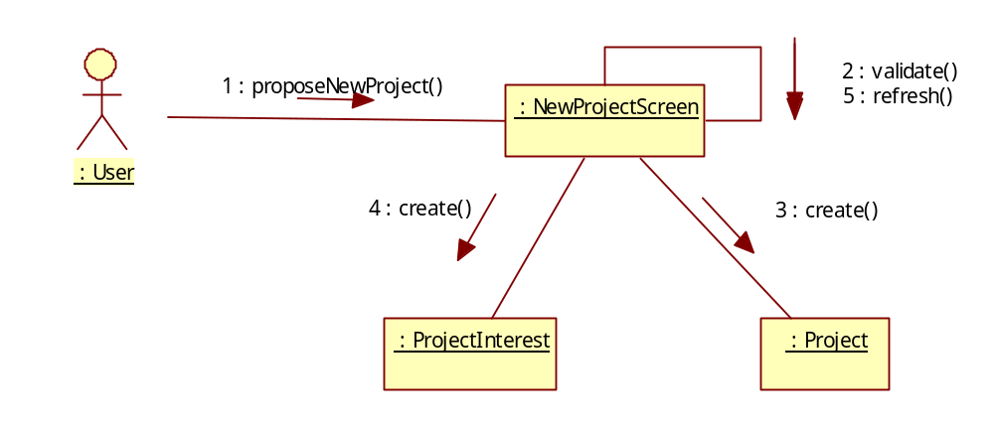

Participating Objects
:

Derived Requirements

